The SCOOP
March 2012 Vol. 26 No. 3
The newsletter for the Knoxville Area Model Railroad Club, Inc.
Editor: Jim Schall, phone - 423 369-2955, email - Schallj@highland.net
Website : knoxmodelrailroaders.com

KAMRI February Club Calendar:
- March 4 (1st Sunday): Regular club gathering.
- March 17 (3rd Sunday): club open house followed by the regular business meeting starting about 4:15. This meeting will include a final annual dues reminder!

Conductor’s Comments –Bruce McElhoe, President
I’m still not sure but I think I survived my first n-scale ops session (?) at our CMOR home. I only pushed one coal car off the end of a trestle. ☺ It’s a lucky thing I was only moving that one car load or… I did enjoy the experience along with the others as we ventured (sometimes off track) around the layout. More good times will be had trying to expand the 1/160 business economy.

One of the fun things I’ve found using my (dumb) phone (as compared to a smart phone) is the ability to get into tight places to take pictures. I was sneaking around and caught a local cop checking out a drugstore I just left. I hope he didn’t see me with all of the whit powder all over my face. Don’t you just hate it when a gust of wind comes up just as you bite into that fresh powdered sugar covered doughnut!
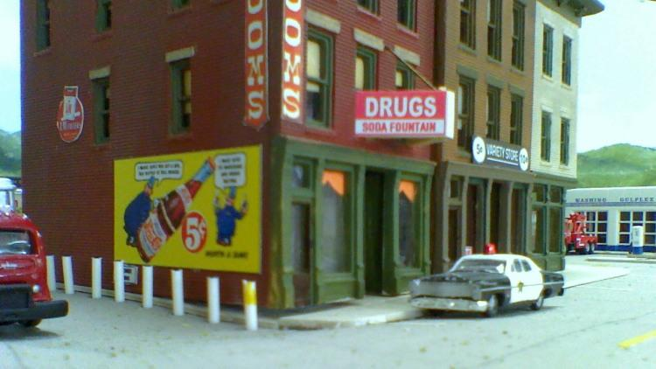

Thought I better lay low and found a great hiding spot off the end off a local branch line industry loading dock. It must be time for lunch as I can’t find anyone around but I’m curious what’s in those crates. Maybe I should behave and just hang loose. Or maybe head back to the variety store and get me a 5 cent soda. Although I’d have to head further down the street and hope that gas station has clean rest rooms.
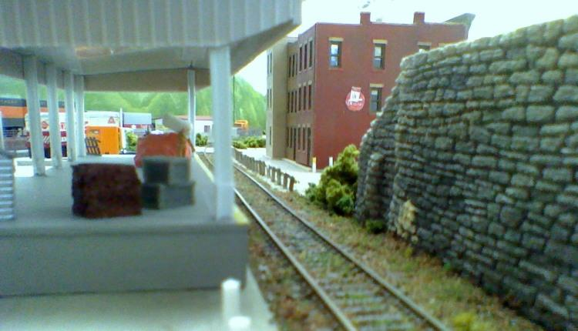

There’s always some twist of a story behind every picture if you let your world shrink down to size – n-scale size that is!
HO Division – Alex Cameron Here are the dates for March, 2012. The first Sunday is March 4, and we will have our regular operating session that day. Operation starts at 1:30. The third Sunday, March 18 will be a run session, since it is still the regular open house for CMOR. We will start about 1:00. There will be Saturday work sessions on March 10 and 24. Thursday work sessions will be on March 1, 8, 15, and 22 starting at 9:30.
The first Sunday in February was also Super Bowl Sunday. In spite of the allure of probably endless pre-game coverage, we had a large turnout of operators. We 12 to 15 people, the most that we have had in a long time, and so had two people assigned to most trains – one as engineer, and the other as conductor. It was a successful session but a lot more chaotic that recent ones.
We had a very good turnout of HO division members for both the International Fest on February 18 and the third Sunday open house on February 19. Many thanks to all members who came and ran trains. The Sunday open house was in many ways busier that the International Fest, because the rainy day brought many people to the CMOR, and we had young operators who tried to turn the railroad into a NASCAR event.
Work session attendance has been better again in February. We have had our usual maintenance items. We have installed a control panel for the narrow gauge switches on Bald Mountain, and now I don’t have to try to decipher my labels when operating there.
We have replaced two of the turnouts in the lead to the mine tipple, and have now operated on that, and it seems to be better. We no longer have shorting problems when pushing the long string of hoppers up that grade, but light hopper cars are still a problem
I have tried using the paint booth, and after the first attempt, we added a manifold to the air compressor. It has an air pressure regulator and an air drier. The regulator will control from about 5 PSI to about 25 PSI, which is the maximum that the compressor will put out. The manifold has two outlets, each with a shut off valve, and with two different fitting to handle air brush hoses, since those don’t seem to have standardized fittings. I tried the booth again after the manifold was installed, and got some experience with different air pressures and so on. However, the exhaust blower kept making more and more noise and so we are trying to fix that again!!!
Curt and I are still operating on Tuesday AM, and frequently have been having others join us. Remember to bring locomotives and controllers for these sessions as well as the first Sunday operating session and for the third Sunday run session.
N/Z-Scale Activities – Larry Burkholder, N Coordinator
Our group survived the museum's International Fest well, with a goodly number of visitors passing through. Thanks to all who came to help run trains. Thanks also to those of you who showed up the day before to help the museum set up for the festival.

On Open House Sunday we had a short training meeting to cover operating procedures, and then spent a couple hours operating. About six different trains were used while the yard crew worked feverously to keep up. All when pretty well considering that it was the first operating session for many there. With many of the industries needing to be serviced from outside the layout, but the card boxes being on the inside, it is necessary to have at least a couple helpers covering the inside when the engineers are outside so car cards can be placed in the setout slots and the engineers can be told what pick-ups are necessary. With four engineers, two helpers, a yardmaster and an assistant, we can accommodate eight members during an operating session. If we have time to run more than four trains in the afternoon the inside helpers can switch off and take a turn at engineer. What's a good railroad name for the inside helper? (Front-end Brakeman??)

Since we need to be interacting more with our visitors and because trying to operate on the outside of the layout interferes with visitors moving past the layout; we will schedule our regular operating sessions for the first Sunday meeting only. If necessary, we can use the third Sunday to make up trains for the next operating session.

I know the museum has a program for which they need some trainmen participation later in March. Please read our President's report to see if and how you might help.

Large Scale Rails – Lance McCold
The division has been busy this month. Lots of work on the O-gauge layout took place to get it ready for the International Festival and open house days. The work paid off at the recent events.

Two of our members showed up on Friday to help prepare for the International Festival. At the festival itself, good time was had by all the large scale members who helped. The O-gauge layout was a big hit at both the International Fest and Sunday open house. It had three trains running and, for the kids, buttons to push that made train sounds. The kids and their parents loved the action.

The S-scale crew is busy working building turnouts for the switching layout they will take to the National Association of S Gaugers convention in Chattanooga this summer.

Now that the O-gauge layout is operating, the American Flyer crew has begun building bench work for a small flyer layout to be build beneath the O-gauge layout.
In the Garden After the spectacular weather and run for the International Fest, we are hoping for similar session for the Girl Scouts 100th Anniversary program on Saturday, March 24th. Bring your Large Scale equipment, and weather permitting we should be running from 10 AM until 4 PM. Even if we have some bad weather, we should have the "O" layout operational.

KAMRI Web Site – Bruce McElhoe, Web Site Moderator - hmcelhoe@aol.com

