The SCOOP
January 2012 Vol. 26 No. 1
The newsletter for the Knoxville Area Model Railroad Club, Inc.
Editor: Jim Schall, phone - 423 369-2955, email - Schallj@highland.net
Website: knoxmodelrailroaders.com

Museum staff has again notified KAMRI that a club door was found unlocked on December 26th. All club members have a responsible for assuring that all club doors and gates are properly secured when leaving the premises.
[Guys it ain’t rocket science twist the latch and check the door after it’s closed. ed.]

KAMRI January Club Calendar:
- 1st Sunday (Jan. 1): Regular club gathering
- 3rd Sunday (Jan 15): Club open house followed by the regular business meeting starting about 4:15.
- 5th Sunday (Jan 29): Club gathering.

Conductor’s Comments - Bruce McElhoe, President
As always, our KAMRI Christmas gathering was well attended and well stocked with all of our favorite edibles and drink. I do want to thank all that helped with setting it all up and the post cleanup. It’s hard to believe that another holiday season is quickly passing into the history books. But the bottom line is the hope that all have had a most enjoyable and rewarding time. Oh! And I hope each of your pikes received some of those much needed gifts.

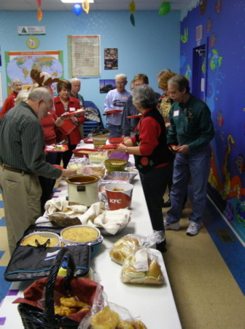
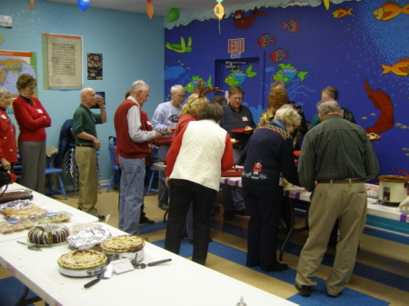

The diner is now open!

Our annual “hear a pin drop” elections ☺ were held during our Christmas gathering. The one big change will be the position of club secretary. Jim Shall has held that position for so long I can’t recall who may have preceded him. For our 2012 season Jim has announced that he can no longer fill that position due to other time conflicting commitments and would not seek re-election. Speaking for the whole club, I want to thank Jim for all of his time and efforts in supporting our club in this position.

Following a vigorous campaign to find suitable candidates, we did find individuals that would step up and backfill the various club board and officer positions for the 2012 season. Having been duly selected, the club officers and Board members for 2012 are listed below.

President – Bruce McElhoe KAMRI Board Members
VP - Vacant HO Rep #1 – Dick Brion (Chairman]
Secretary – Ken Klipple HO Rep #2 – Curt Goff
Treasurer – Bob Strickland N/Z Rep #1 – Phil Brooks
HO Coordinator – Alex Cameron N/Z Rep #2 – Loren Kneeland
N/Z Coordinator – Larry Burkholder Large Rep – Jim Schall
Large Scale Coordinator – Lance McCold

As always, the Christmas Garden Railroad was well received again. We all owe Ken Klipple a big/huge/enormous thank you for taking the lead into making this year's garden another great success. Thanks also to all of you who braved the cold nights to operate the garden. It's a lot of work setting up and taking down everything each night. We need more of you to help out next year.

Thanks again to all of you who helped with the museum's Gala. The feedback I had from Carroll Welsh (CMOR) was that she was quite pleased with the return on investment. It just may have been the good bartending that helped loosened a few pockets. ☺ She also was very thankful for all the support our club has provided during the year.

One final note, 2012 DUES ARE DUE. The new amount is $50 payable to KAMRI. You may hand your due to Bob Strickland at one of our gatherings or via mail addressed to Bob @ 118 Wind Chase Drive, Madisonville, TN 37354.

HO Division – Alex Cameron
Here are the dates for January, 2012. The first Sunday is January 1, New Year’s Day (or is that New Year Day). Although I am sure that many people will be watching football, there is also some interest in operating, and so we will have our regular operating session that day. Operation starts at 1:30. The third Sunday, January 15 will be a run session, since it is still the regular open house for CMOR. We will start about 1:00. There will be Saturday work sessions on January 7 and 21. Thursday work sessions will be on January 5, 12, 19, and 26 starting at 9:30. There is a fifth Sunday in January, the 29, and that will be a work/run session.
We helped with the CMOR Gala on Friday night, December 2. Many thanks to all the club members who came and helped running trains, manning the bar, and serving wine. Unfortunately, we only had a few visitors to see the trains. The one informal report that I heard was that the CMOR did very well with the Gala.
The first Sunday was then the KAMR Christmas party instead of our usual operating session. There were about 40 people at the party and I hope that all had a good time.
Work session attendance has been sporadic again in December. We did do a major pick up and clean on the club area before the Gala, and now of course can’t find anything. We have had our usual maintenance items. I don’t recall any note worthy problems at this point.
I have now built a curved turnout to replace the troublesome one on the lower loop. That replacement will be done when we can schedule it so as to cause minimal disruption to normal operation.
After an unsuccessful struggle to fix the noisy blower on the paint spray booth, we have decided to just live with it a while, and see how bad it is in actual operation. If any club member wishes to use the spray booth, see me (Alex Cameron).
Curt and I are still operating on Tuesday AM, and frequently have been having others join us. Remember to bring locomotives and controllers for the first Sunday operating session, and for the third Sunday run session.
N/Z Division - Larry Burkholder
I hope everyone had a great Christmas and if you got any new railroad toys bring them by the club for show and tell.

Our latest efforts have focused on designing a "interchange yard" to give us some place to send cars off the main route, such as to Memphis or Knoxville. The goal is to minimize turnouts needed to cover about six locations being fed from two mains. Separate yards from each line would require about twelve turnouts. We have designed a single yard being fed from both lines through a "Y" switch, cutting the turnout count in half. We have salvaged some automatic Atlas switches from a donated layout in the basement to use for the yard. Automatic switches will be required because the yard lies outside our reachable working area. Several additional crossovers are required to improve access. With these additions we should be ready to start operations.

Once again our N scale division stepped up to fill a club need by joining Ken Klipple to man the garden railroad for a special children's program by the museum the morning of December 14th. With no general club announcement in advance, the program sneaked up on us. I was not available, but an emergency call the night before got Bob Mugge to agree to come out to help. These things need to be planned and manning requirements filled well in advance. Thanks to Ken for remembering it and contacting me for help the day before.

Bob Strickland and I are on for manning the last Christmas garden run New Year's night so we will be at the club Sunday. Most of the football games are on Monday, so come to the club Sunday and start the year off right by running trains.

Large Scale Rails – Lance McCold, (Jim Schall, standing in for Lance)
The garden layout has been a problem this year --- attendance has been down and because of Christmas falling on the weekend it has been difficult to find operators to come in over the holiday weekends. Although Christmas falls on a Tuesday in 2012, we should review our schedule and requirements next year.

Large scale guys have taken our last two Wednesday meetings off in December after lifting the Lionel layout to provide space underneath for an American Flyer loop. The three S scalers have 12 feet of 2 foot wide modules that are in the process (sort of) of building a industrial switching layout. (I have learned that

