The SCOOP
October 2011 Vol. 25 No. 10
The newsletter for the Knoxville Area Model Railroad Club, Inc.
Editor: Jim Schall, phone - 423 369-2955, email - Schallj@highland.net
Website : knoxmodelrailroaders.com

Conductor’s Comments –Bruce McElhoe, President
We are quickly getting into the fall season of things related to trains. We had our first outing with the portable layout, our first CMOR request for our support using the new form we provided, and we have a busy month of available train events for our choosing.

I do want to thank all that helped with getting our portable layout packed, shipped, setup, and operated at the Railgrass Fall Festival in Erwin, TN. Saturday operations were handled by Larry, Phil, and Greg. Sunday was in the hands of Loren and me. We were flooded with continuous amazement and compliments of the visual quality of the layout. Folks were even more dazzled with our DCC operations on Sunday thanks to Loren for bringing his booster. At one point Loren and I had four trains running at the same time. I was even asked to open an engine to show off the DCC circuitry. I quickly got the impression that folks could not believe how well n-scale trains ran and could operate so smoothly in switching scenarios. The ole ego really got inflated. I do admit that only northwestern railroads were showing their colors on Sunday. ☺
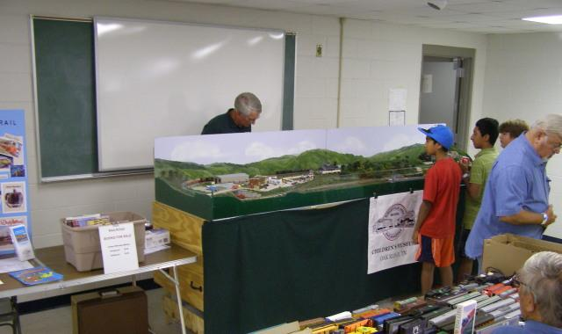
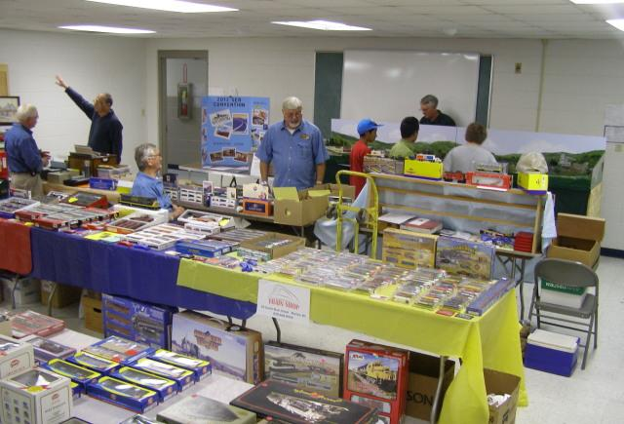
On Friday evening October 21, 2011, from 5:30-7:30 pm, Children’s Museum of Oak Ridge (CMOR) will be hosting preschool children and their families visiting CMOR as they did this past spring. The Large Scale and other KAMRI club members were kind enough to run trains for the evening, which everyone enjoyed. CMOR has again submitted a request for KAMRI to have the garden railroad up and running (weather permitting). And, if the weather isn’t cooperative, to have the HO and N-scale rooms open for these visitors. As always, we need volunteers to cover the visit and be prepared to run all layouts.
Did you know that it’s about time to start planning our Christmas party! The first real sign of the upcoming event is the CMOR announcement of their 10th Annual Gala “Morocco: Casablanca’s Mystique” on Saturday, December 2, 2011. Their schedule typically means the date of our party will be the following Sunday, December 4, 2011. That will be one of the topics of discussion at our October monthly meeting after the 3rd Sunday open house.
October Club Event Calendar:
- October 2 (1st Sunday): KAMRI regular club gathering.
- October 15: KAMRI hosts visit by Garden RR Club from Ohio
- October 16 (3rd Sunday): KAMRI open house and meeting
- October 21: After Hours Event at CMOR
- October 30 (5th Sunday) : KAMRI regular club gathering.

Regional Items of Interest:
- All October Weekends: Secret City Scenic Excursion Train “Fall Colors” plus the special “Halloween Spooktacular” on Oct 29 and 30 [http://www.southernappalachia.railway.museum]
- October 14-15: French Broad e’N’pire Autumn Rails, Hendersonville, NC
- October 21: The Chambers After Hours Event at CMOR
- October 22: Three Rivers Rambler pumpkin steam train excursions. [http://www.threeriversrambler.com]
The Garden RR Social:
This is an update to the planned visit by around 50 members of the Garden Railroad Club from Ohio [http://www.cgrs.org]. Our large scale contingent will be hosting our visitors to a Saturday evening (Oct 15) of garden railroad action barring weather issues. There will be a cookout with a $5 per head fee starting around 5:30. Please let the Large Scale Coordinator know if you will be attending due to a somewhat limited food supply.
I would encourage other club members to participate so we can have all layouts up and running for our guests. This will be fun so I'm going to assume that I've railroaded all of you into attending this gathering.

HO Division – Alex Cameron
Here are the dates for October, 2011. Regular club Sunday meeting is on the first Sunday, October 2 which will be an operating session. The third Sunday, October 16 will be a run session, since it is still the regular open house for CMOR. We will start about 1:00. There will be Saturday work sessions on October 8 and 22. Thursday work sessions will be on October 6, 13, 20, and 27 starting at 9:30. There is a fifth Sunday in October, the 30th, and that will be a work session.
We did operate in September with a small crew, but it was very chaotic because of interruptions. The third Sunday open house was well attended with many visitors. Remember to watch those visitors during the open house!
Work session attendance has been better in September. We have had the usual maintenance items. There are usually 3 or 4 items that have to be looked at after an operating session. We have installed new switches and track for Schrock meats in South Wyeth. This allows two tracks there, one for stock cars, the second for reefers, shipping. Etc. Not too much progress on the narrow gauge this month.
With some extra man power, we have been working on installing the paint booth in the CMOR work shop. It is a vented paint booth that will exhaust through one of the windows, and will be available to any KAMR member. We have a compressor (actually, we may have two) and an air brush. I am not sure that if any of the paint that we have is useable.
Here are more changes to the basic operating standards. We started handing out copies of this at the September operating session. Now we just have to get people to read them.
KAMR operations
1) We are using a 4 cycle car card system. Each freight car, and each passenger head end car has a car card associated with it. Each car card lists the car’s road name, number, type of car and car length. Each car card has a pocket in it to hold a 4 cycle waybill. Cabooses do not have car cards.
2) Some cars, which also operate as a ‘block’ of cars, do not have a car card for each individual car. At the moment, all of those cars are hoppers, and instead, there is a ‘Hopper Block’ car card, which lists the type of cars in each hopper block. Other than that, the car card is treated as a regular car card. Hopper block car cards are used to govern the movement of the hoppers to and from the large coal tipple, the coal dock in the harbor, and the Chattanooga coal drag. They also govern the movement of hoppers between the mine at Hoods and the power station at South Wyeth.
3) Each ‘Town’ has a name. Currently the towns are (from North to South) South Wyeth, Raccoon Creek, Hoods, Beaver, Knoxville, Lumberton, Upper Seaside, Lower Seaside, Harbor, and Grain Coop. These locations are switched by freight train locals and by passenger trains where there is a passenger station. Each town has a car card box. Each box has 3 sections, labeled: Set out, Hold, and Pickup. When a freight train switches a town, after the cars are spotted at their correct industries, the car cards are placed in the Set Out section. The car cards in the Hold section are left alone, and any cars in the pickup section are placed in the train to be returned to Knoxville.
At towns with a passenger station there is a car card box for passenger car cards.
4) A waybill is the document that says where each car is to go. This is usually some industrial location. It also lists where the car is coming from and the contents. Each waybill also lists the type of car it belongs to, and it has four sections, labeled 1, 2, 3 & 4. When a waybill is put in a car card, only one of the sections is visible, and that is the current routing for the associated car.
5) Each train that operates has a train card that gives the basic instructions about where that train is to go, and what it is supposed to do. There will also be a car card for each of the cars in that train. They are placed behind the train card, and the whole package held together with a rubber band. The car cards should be sorted in the order that the cars are in the train.
6) All the switching jobs that leave the yard (Knoxville) are turns. That means that they go to the location that they are to switch, and then retrace their route back to Knoxville. That means that all the trains need to have the locomotive and caboose swap ends. This should be kept in mind when planning switching moves. This also means that steam locomotives will be running tender first when returning to Knoxville. The only location to turn a locomotive other than at Knoxville is on the short turntable in Raccoon Creek. For operation purposes, the two reversing loops don’t exist.
7) When a train leaves to switch a location, along with the train card, there will be a car card for each car in the train. The ‘To:’ section of the waybill shows where that car is to be placed.
8) When switching a location, the "From:’ section of the way bills in the pick-up box show where those cars are to be found. All of the cars in the pick-up box are to be returned to Knoxville. There are exceptions. The Lumberton turn may have cars that are to be left at Upper Sea Side, and the Upper Sea Side turn may have cars for Lumberton. The Raccoon Creek turn may have cars for South Wyeth, and the Hoods/South Wyeth turn may have cars for Raccoon Creek. The Harbor turn may have cars for the Grain Coop, and the Grain Coop turn may have cars for the harbor car float. The Hoods/South Wyeth turn has hopper cars that shuttle between the mine at Hoods and the power station at South Wyeth.
With the exception of the Hoods/South Wyeth hoppers, these cars should be spotted on a clear track in the adjacent town and a “re-spot” card should be placed in front of the car card(s), secured with a rubber band and placed in the "Pickup" box of the adjacent town. The next "turn" for the adjacent town will spot the car(s) at the proper location(s).
All other cars for other destinations are to be returned to Knoxville.
9) In the case where there are too many cars destined for a particular industry, the excess cars should be spotted where they will not interfere with train operations. A “re-spot” card should be placed in front of the car card(s), secured with a rubber band and placed in the "Pickup" box of the appropriate town. The next turn to that town will spot the car(s) in their proper location.
10) In all cases, if a car is a ‘hold’ car (its car card is in the hold box, not the pickup box) that car may be moved to accomplish the switching, but must be returned to its original location when switching is completed. Any car that is set out should be placed behind any car that is a hold. This makes it easy to pick up that car at the next operation session
Curt and I are still operating on Tuesday AM, and frequently have been having others join us.
Remember to bring locomotives and controllers for the first Sunday operating session, and for the third Sunday run session.
N/Z-Scale Activities – Larry Burkholder
No report at this time.

Large Scale Rails – Lance McCold
In the Garden
Most of the track laying is completed on all six loops in the garden layout. We still have one siding and the installation of the double crossover to complete. The power pack for the layout has been upgraded to support five loops with the sixth loop powered by a separate MRH pack.
Large Scale will be hosting the Columbus Garden Railway Society in the garden on September 15th for an evening run and dinner. We will begin setup mid afternoon with dinner around 5:30 PM. Please check with Ken Klipple for more information.

KAMRI Web Site – Bruce McElhoe
Some Important Links:
Searchable online KAMRI library. [http://connect.collectorz.com/users/kamr/books]

2012 NMRA Southeastern Region Convention. “Tracks to the Smokys”
[www.tface.org/2012.htm]

