The SCOOP
January 2010 Vol. 24, No. 1
The newsletter for the Knoxville Area Model Railroad Club, Inc.
Editor: Jim Schall, phone - 423 369-2955, email - Schallj@highland.net
Website : knoxmodelrailroaders.com

As the New Year begins we need to take a moment to remember Lew Hedrick, Rick Heller, and Doc Arms, three of our KAMR brothers who passed away in 2009. All will be missed by their families and friends.

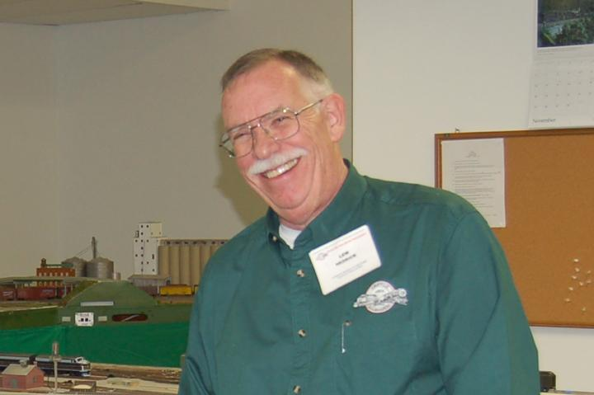
Lew Hedrick
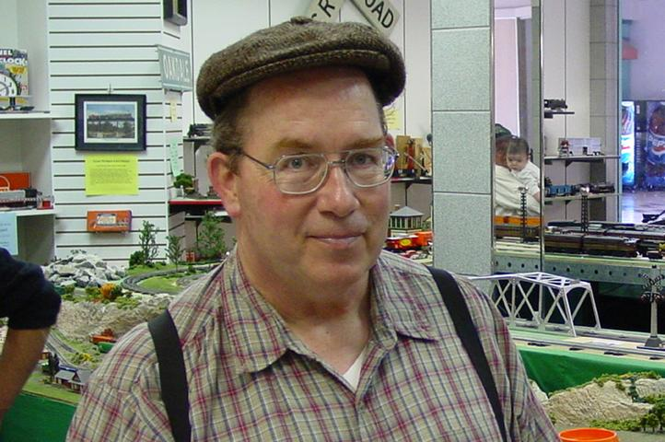
Rick Heller

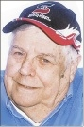
Donald “Doc” Arms

Conductor’s Comments - Larry Burkholder, President
The holidays are essentially over and we can get back to running trains. I hope everyone had an enjoyable time and got lots of railroad gifts.

There was a short business meeting that starting about 4:15 following our regular first Sunday (3rd) get together. Our Open House Sunday is the 17th. There are five Sundays in January, so the club will be open on the 31st as well.

Having been duly elected, the club officers and Board members for 2010 are listed below. With a change in our Bylaws we have added three new official officers; two VP's and we made the Large Scale Division Coordinator position an office position like the HO and N scale division Coordinators.

President - Larry Burkholder KAMRI Board Members
VP - Curt Goff HO Rep - Dick Brion
VP - Brian Woodruff HO Rep - Pete Hoke
Secretary - Jim Schall N/Z Rep - Phil Brooks
Treasurer - Bob Strickland N/Z Rep – Charlie Womack
HO Coordinator - Alex Cameron Large Rep - Jim Schall
N/Z Coordinator - Bruce McElhoe
Large Scale Coordinator - Brad Tutt

There are no special events on our or the museum's calendar in January, but in February the museum will host their International Festival. We will be expected to have our club open for visitors. It will be a Saturday, probably from 10 to 5, but I am not yet sure of which one. I will advise you as soon as I know more.

The Christmas Train Garden seemed to be a success again. As usual, the crowds didn't materialize until the later weekends, but there was a good steady flow the two weekends I worked. We all owe Ken Klipple a big thank you for the effort he put into making this year's garden the best we've had. Besides being there almost every night (one Saturday he set up and operated all by himself), Ken was essentially responsible for all the electrical work, including the building and train car decorations. For the most part everything ran trouble free. Ken's already got big ideas for improving things for next year. Thanks also to all of you who braved the cold nights to operate the garden. It's a lot of work setting up and taking down everything each night. We need more of you to help out next year. I am sure Ken can use a lot of help taking down the lights. We will advise you when he wants to schedule a work session.

I hope everyone read the email I forwarded from member Chris Zorn. Madison has a lot of expensive rehabilitation ahead of her and we can help by contributing any way we can. The Zorn's are offering "I Support Madison Zorn" bracelets for $5. If you wish to purchase one, contact Chris at czorn@fireincidentnetwork.net or czorn25@yahoo.com.

Thanks to all of you who helped with the museum's gala last month. The numbers are in and it was the most successful gala ever, netting $50,000.

One final note, 2010 DUES ARE DUE. $25 to Bob Strickland asap.

HO Division – Alex Cameron
Many thanks to all HO Division members who turned out in force for the CMOR Gala on December 4!!! Your help and support is much appreciated.
Here are the dates for January, 2010. Regular club Sunday meeting on the first Sunday, January 3. The third Sunday, January 17, will be an operating session, starting about 1:30. Saturday work sessions will be on January 9 and January 23, starting about 9:30. Thursday work sessions will be on January 7, 14, 21, and 28 starting at 9:30.
The attendance on Thursdays has been down because of the holidays. Saturdays has been only 2 or 3 hardcore attendees.
We had fair attendance again for the December operating session, with enough people to run most of the trains. We continue to run the four train passenger train schedule, and have been getting the bugs out of that.
We have been laying narrow gauge track on the mountain in the corner. The engine terminal work creeps along. The curved switch at the Knoxville end of what will be a passing siding on the Lumberton modules seems to be working well, but we have been having problems with the lift bridge there. I think that use has caused stuff to shift, and the track across the gaps needs adjustment.
We had a ‘phantom’ short’ in Raccoon Creek during the operating sessions which I could not recreate later. A problem did show up there when operating on a later date, and I have about concluded that one of the slide switches on the dual gauge ladder there is bad.
We also readjusted the location sensors on the lower loop, and those are now operating better. We added brighter lights (LEDs) for the sensors that are in tunnels and those work better now.
Curt and I are still operating on Tuesday AM, and frequently have been having others join us. Several times in December we have had 4 or 5 operating on Tuesday AM.
Remember to bring locomotives and controllers for the operating session.

N/Z-Scale Activities - Bruce McElhoe
I’m trying to notice if the days are getting longer yet. However, due to global warming, it’s just too cold outside to notice. I guess that makes time for model railroading. We have had consistency with running under DCC controls. We continue to acquire or modify more engines with decoders. Part of the recent learning curve was during programming an A/B/B/A set of F-units don’t use the DT100 throttle to program the back pair of units for reverse direction when the other units with the same address are on the layout. I was trying to reprogram one unit on the programming track but using this throttle also tweaked the other 3 units on the layout. My thanks to those HO guys that stepped in (I don’t recall begging to loudly) and stated that this is a quirk of this throttle. We pulled out the recently acquired DT400 and corrected the mayhem. Another DCC lesson learned!

Progress has been creeping along with the installation of the siding into the ice house. The rails have been laid and are awaiting ballast and power drops. The new tracks also will have a lead to a yet to be identified industry. Other activities include the final placement and landscaping of the Strickland Mercantile at the intersection of the road leading through Bluecollarton and the pig yard.

Large Scale Rails – Brad Tutt
I hope everyone had a great holiday and received train equipment or money to support our hobby for Christmas. I got a restored 1951 Pacific 4-6-2 and a log dump car for my Classicville S gauge. Dot and I also spent two weeks re-building our coffee table N scale Christmas layout including new snow ballast. I even gave Dot a new N scale ALCO for our 30th Anniversary. What a way to keep the marriage going!

Once again our division increased in membership and our library got larger. We are very thankful for each and every member and hope the dues are worth the return. Please remember that your 2010 club dues are now payable if you have not already paid. You can mail your dues to Bob Strickland or bring to club meetings and drop off with division or club leaders.

We have many items to keep us busy including G gauge trains to service after the Christmas operations, building maintenance, lights and decoration packing and such. Contact Ken or Mark if you can help. We also need to get busy with the layout design for our new CMOR layout and get started. We also have the test track to finish and lots of opportunity to scenic work on the triangle layout while we get our thoughts together on the new layout.

Come by and enjoy your club and keep the trains rollin’

KAMRI Web Site – Bruce McElhoe, Web Site Moderator
We’re getting off into another year of model railroading. The holidays caused some delays with getting the Scoop out but that too shall pass. This forum is a great tool for sharing information and as always I encourage all to use it.

