The SCOOP
July 2009 Vol. 23, No. 7
The newsletter for the Knoxville Area Model Railroad Club, Inc.
Editor: Jim Schall, phone - 423 369-2955, email - Schallj@highland.net
Website : knoxmodelrailroaders.com

KAMR members, just a note to let you know that Donald "Doc" Arms has passed away late Wednesday evening. Doc was a charter member of the KAMR and a member of the original Oak Ridge Model railroad club dating back into the 1950s. Doc was a retired Southern Railway engine man, and an avid ham radio operator. He was always a delight and made sure that we always ate well on our club road trips (and at least once on every trip at Cracker Barrel!!)

Conductor’s Comments - Larry Burkholder, President
In following our usual tradition of trains taking presidency, in spite of the holiday weekend the consensus seems to be that we have a regular meeting on Sunday, July 5th. To keep things short and in anticipation of a limited turnout, we WILL NOT have a business meeting. Our open house Sunday is July 19th.

Thanks to everyone who helped with the model railroad summer camp the week of 22nd. Eight of us total worked with eleven kids, although the average help was about four a day. This was one of our best camps in that the kids required little discipline and did great work with their modules. Hobby Town and Atlas donated buildings, scenic materials, track, and railcars.

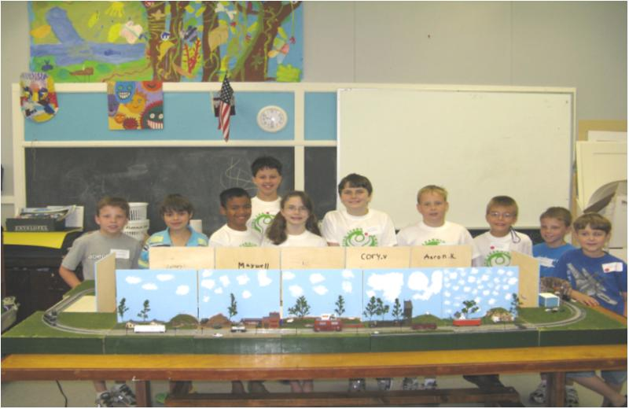

Over the weekend of June 19-21, I attended the NMRA Southeastern Region's annual meeting in Pensacola, Florida. Attendance was low, with about sixty registered out of about 1037 current SER members. The economy seemed to be the main problem with attendance. I was the only representative from the Smoky Mountain Division. Several clinics were interesting and the chance to meet other modelers and friends always makes it worthwhile. Unfortunately, a prototype tour of the CSX yards was canceled by CSX at the last moment. The train show had about twenty vendors and seven different layouts covering G to Z. One dealer had the new T-scale (1/440). The Smoky Mountain Division hosts the convention again in 2012, probably in Pigeon Forge or Gatlinburg. Even if you are not an NMRA member we will appreciate your help. Planning has already started.

HO Division – Alex Cameron
Here are the dates for July, 2009. Regular club Sunday meeting is on the first Sunday, July 5. The third Sunday, July 19, will be an operating session, starting about 1:30. Saturday work sessions will be on July 11 and July 25, starting about 9:30. Thursday work sessions will be on July 2, 9, 16, 23 and 30 starting at 9:30.
The attendance on Thursdays has been about average. Saturdays has been the hardcore attendees.
We only had a few for the June operating session. One man crews for most trains but it was a good operating session. All of the trains were run, except for one of the through freights.
The main visible work seems to be on the mountain in the corner, and a rebuild of South Wyeth. We continue to work on operating problems as we encounter them. Achieving a reliable roster of locomotives is one area that needs work.
Curt and I are still operating on Tuesday AM, come on by!
Remember to bring locomotives and controllers for the operating session.
When you can, come and see what has been happening. Come and runs trains, or just hang around.

N/Z-Scale Activities - Bruce McElhoe, N Coordinator -
Eureka n-scalers, we have DCC!

At our June 3rd Sunday gathering we successfully setup the layout for DCC operations and operated trains! It was marvelous beyond our own skepticism. Well anyway, we did run a few engines and a short train or three around the layout. I also had to play with my PCM E7 just to try out the other sound options. Little did I know that there is a wee engineer in the cab that upon command actually radios a dispatcher. I even attempted a corn field meeting on a fellow n-scaler. Boys and their toys!

So it looks like we now have a viable option to operate DC or DCC (mixing power types not allowed). It is possible to switch between power types in just a few minutes although we are still on the inexperienced side of things so I’m sure that for the next few times it’ll take a wee more time. With this revelation of operation modes now available we are trying to introduce some organization to the chaos. A registration log of DCC engines and their address codes is being drafted to track which code is assigned to which engine. This is to minimize potential duplication of address codes wherever possible. At this time due to the small number of DCC equipped engines, code registration is basically first come first serve unless otherwise requested. Noting that it is not our intension to say you cannot select a certain code for your own reasons but only to minimize multiple engines with the same code running at the same time. It is suggested that code 03 be used for new units yet to have selected a number, testing purposes, or possibly visitors units

We are also going to have a dry marker board setup to keep a running list of engines on the layout at any given time. Whenever an engine is placed on the layout, its identification is written on the board. There will be a DCC information notebook with the layout that will have reference documentation of subjects such as DCC operating rules of the road, throttle ABC’s, and the engine registration listings. As far as wholesale operations, we are still restricted by the number of throttles available. We also have wired IR, and radio capabilities. So we will need to discuss future throttle purchasing. Typically, throttles are owned by individuals with the exception of a core unit (that we currently have) although it’s a discontinued design that is no longer supported by Digitrax for servicing or upgrading.

Z-Scale:
Bob Sanders has joined Larry Burkholder in moving the Z scale layout towards completion. Check out the new covered bridge and houses on the outskirts of town that Bob built. Two cross buck rail crossing warnings are built and waiting to be installed. Pretty soon the gates will be opened and the river and lake will be filled.

Large Scale Rails – Brad Tutt
This month’s attendance on Wednesday evenings has been fantastic with new members, new ideas and minimal progress on the layout in the club area. However, we have been active with a field trip to Don Niday’s F scale layout. Everyone had a great time at Don’s and learned a lot about F Scale (1:20.32) vs F Gauge Standard (70.62mm ) vs Fn3 (45mm narrow gauge). Great stuff and if interested, visit Don’s website at www.IronCreekShops.com for additional information.

As always, we continue to follow the requests of our members and had a great operating session for special guests. The club is by and for the members with minimal requests from the Children’s Museum. However, the only member (thanks Ken) was present for garden operations for the June Open House Sunday. Thanks to him, the museum guests had some garden train to view. PLEASE remember the garden layout is a “club layout” for everyone, not just large scale division. We need true Volunteers from all scales to make sure that we fulfill our obligation to CMOR.

With the longer daylight hours, we plan additional field trips in the near future so keep checking the club calendar.

Tom Knight will be helping Mark in Pigeon Forge at his “Christmas In July” train run. You may not know but Mark has a 4,000 sq. ft. tent (like the Holiday Express at UT last Christmas) put up at the Christmas Place.
He will be running trains with Mark for the entire month of July. Noon until 9:00 PM every day.
Come by and see us some time.

Give a toot, don’t pollute and keep you right-of-way clean!
KAMRI Web Site – Bruce McElhoe, Web Site Moderator
We now have an updated club membership, clubhouse map, and management listing sticky post for visitors of our web site to reference. If you have any other suggestions along these lines drop me a note.

Don’t forget! Our web site address is: www.knoxmodelrailroaders.com.

