The SCOOP
June 2007 Vol. 21, No. 6
The newsletter for the Knoxville Area Model Railroad Club, Inc.
Editor: Jim Schall, phone - 423 369-2955, email - Schallj@highland.net
Website : knoxmodelrailroaders.com

Conductor’s Comments - Larry Burkholder, President
The main news for June is that the Children's Museum has decided to remain open on Sundays this summer and close on Mondays instead. That means we could continue to hold our open house on the third Sunday. Normally in June, July, and August the museum was closed on Sundays, so we switched to the third Saturday for our open house. Our literature says the third Saturday and we could still do it that way if we wish. Give it some thought and we will decide at our business meeting on June 3rd. One important difference is that the museum doesn't open until 1:30 pm on Sundays, whereas it opens at 11 am on Saturdays so our day would be that much longer.

As you all might know by now, Charlie Womac's father passed away a couple weeks ago. Our condolences go out to Charlie and his family. Bob Strictland and I had the honor of serving as pall bearers at the funeral. Iris was a frequent visitor to our club with Charlie. In a tradition the club recently started, in lieu of flowers a donation of $50 will be made to the Children's Museum in his memory.

Although it is not until mid-July, I am asking now for volunteers to assist with the Children Museum's Model Railroad summer camp we do each year so you can make your plans and let me know well in advance. This year it is scheduled from 9 to 12 each day the week of July 23rd. We will again be making N scale T-TRAK modules. There should be ~15 kids ages 9 to 12. Atlas Model Railroad Co. is donating building kits, cars, and a couple engines. If you are available that week please volunteer and let me know soon. You do not have to be available every day if you can't do that. Any help is appreciated.

With travel plans and visitors in the summer, we sometimes can't make the open house Sundays. For N and HO this isn't a big problem because we have more members who can fill in. Running the Garden Railroad, however, can be a problem since only a couple guys regularly show up anyway. We need to have a couple other members from the Large Scale Division learn how to set up and run the G scale operation so it can be covered in a time of shortage.

This past weekend I had the pleasure of attending the NMRA Southeastern Region annual meeting in Cartersville, Georgia. About 300 registered. The meeting consisted of proto and layout tours, clinics, a model contest, a train show, and a banquet, and of course a business breakfast meeting. A few other club members attended just for Saturday. If you are a member of NMRA you are automatically a member of the SER. Attending one of these events is a great way to be able to appreciate what the NMRA can offer, learn new techniques, and make good friends. If you love model railroading you should support the work the NMRA does by becoming a member. While there is much you can get out of being a member and participating in the activities it isn't just about what you get out of it, but also about what your support gives to the hobby. Next years annual meeting will be in May at Lake Junaluska resort west of Ashville.

HO Division – Alex Cameron
Here are the dates for June: Regular club Sunday meeting on June 3 and 17, starting about 1:30. Thursday work sessions are on June 7, 14, 21, 28, starting at 9:30. Saturday work sessions on June 9 and 23, starting at 9:30.

Larry has comments about the third Sunday open house for the Museum during the summer. Read his section. Depending on the decision at the business meeting on June 3, dates for the third Sunday could change.

Attendance during May has been mostly by the 5 or 6 regular attending members, with a few exceptions. We had some control problems on the third Sunday, and I have a hypothesis about that, which I will test at the next opportunity. Generally, operation has been quite reliable as we work on any problems that we find.

All the wiring for the mine loop section has been completed and tested by running a locomotive over the entire track. That found several problems that have been fixed. Much of the track in the yard is without electrical drops, and that is now being worked on.

I finally determined the correct way to install the standard gauge/narrow gauge crossovers. The two that have been installed are quite reliable, but rough. We patched the roadbed in that section, when we should have removed the Homosote and replaced it, because the old roadbed had super elevation in it. So, we will replace the Homosote in that section, then install the 3 crossovers, and then lay the standard gauge lines to match.

We also have a design for the yard throat at the west (mine loop) end of the yard, and will work on that when the necessary turnouts have been bought.

Remember that the third Sunday is a run day (unless we change it to the third Saturday), so come and run trains. Or not. Just come and see what has been happening.

N-Scale Activities - Bruce McElhoe, N Coordinator - hmcelhoe@aol.com
N-Scale Activities - Bruce McElhoe, N/Z Coordinator - hmcelhoe@aol.com
It’s now June and the beginnings of summer and vacations is upon us. I thought I’d post a picture of a good fishing hole that seems to be getting more and more attention. Great trout holes in the white water below Clogderup Dam. Rumor has it that the elusive fresh water Macho Shark has been seen by boaters near this site. (photo next page.)

At our last open house gathering my intension was to tinker with some switching scenarios. Well, things didn’t pan out due to events that kept some of my fellow n-scaler’s away and priority became running trains and talking with museum visitors. I intend to try again at our 1st June gathering. We are due for a little change of pace other than just working on the railroad. I place to put in electrically gapped 5-inch connector tracks between the bridge and John Deere modules and disconnect the power connection at this point. This will allow independent control using the East and West lead selector switches. This will be necessary using analog during any operations. I promise not to let the smoke out. ☺

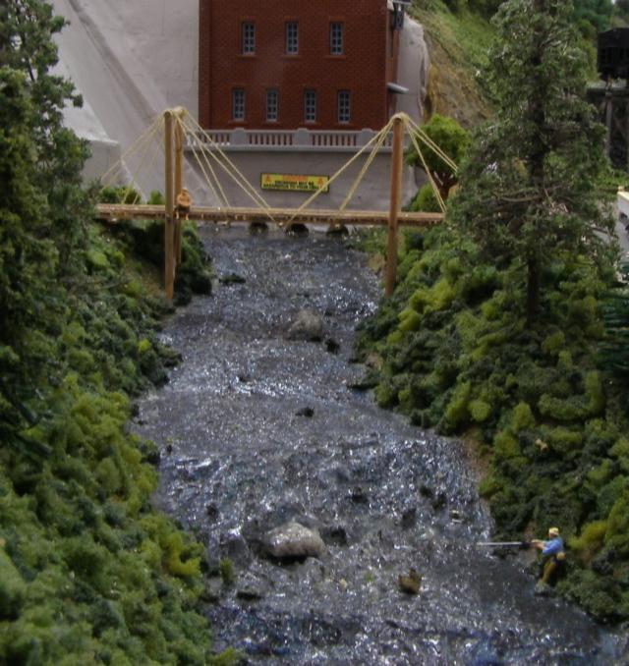

Since the last issuance of the Scoop the approach road from the army base up to the bridge has been completed. We only need to add some bushes and a few trees and we can call it a wrap. We are accepting suggestions for the name of the base so drop over to the small side and offer up some ideas.

I will close for now by encouraging all of us to continue utilizing our web site at www.knoxmodelrailroaders.com. Sharing anything about trains (and food) is good!

Large Scale Rails - Jim Schall
Nothing exciting going on at the Mall just now. Lance is recovering from minor surgery and Rick seems to be back in the saddle again. Corky Ford and I attended the SER convention (and train show). I had three models entered in the model contest and I took first, second and third place in the category that they were entered in (but there were no other entries in the category so I cleaned house (or won by default.)) The models were also the only S scale in the contest room, so I kind of showed the flag for S scale.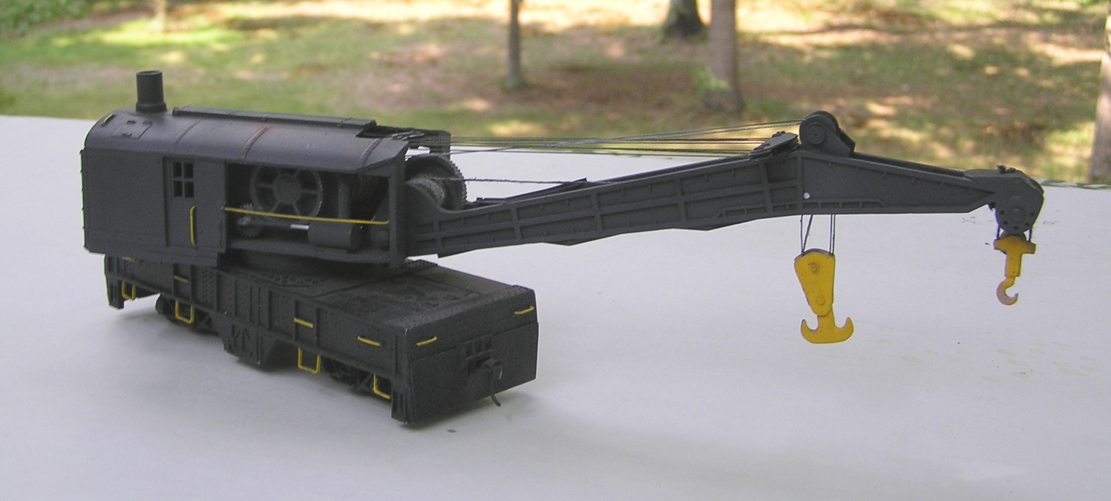

The derrick is a bash of a Lionel crane which scaled out as an S scale 200 ton Bucyrus crane. I chopped it down in length to be match that of a 150 ton crane, opened up the side, added gears and pulleys(from various bottle caps), added the reeving (cabling that lifts the crane and hooks) and scratch built the hooks. It is modeled after the Lehigh and New England’s crane #700. (It took second place in the Maintenance of Way category at the SER contest.)

Activities Calendar
In an effort to get more of us to use our web site the calendar has been moved to knoxmodelrailroaders.com. This should get more of us to the site and hopefully to participate in the exchange of ideas and info that is found there.

