The SCOOP
May 2007 Vol. 21, No. 5
The newsletter for the Knoxville Area Model Railroad Club, Inc.
Editor: Jim Schall, phone - 423 369-2955, email - Schallj@highland.net
Website : knoxmodelrailroaders.com

Conductor’s Comments - Larry Burkholder, President
Key dates in May are our regular meeting date, Sunday the 6th, and Sunday the 20th for our museum open house day.

For those of you who are NMRA members, you are also automatically members of the Southeastern Region. This year's SER annual meeting will be held May 18th and 19th in Cartersville, Georgia. There is much to do... home layout tours, numerous clinics, model contests, a train show, outside tours, spouse non-rail activities, and lots of camaraderie. There are also a number of things to see around the area. Individual registration is only $35 and non-rail spouses cost $25, including the banquet. I got a room for only $49 per night. I highly recommend going. If you are interested you can contact me (865-408-9903) or go the web page www.piedmont-div.org/ser2007 .

I have noticed a significant reduction in attendance these last few months. At the last open house there were a total of about ten members, the same ten that are always there. We have fifty-four active members. If forty-four of you have a problem of some kind, I need to hear about it. Please contact me if there are any issues that make the club less interesting to you. The club needs to offer areas of interest to all members. I know we can't please everyone, but ten out of fifty-four is not a club, it's just a gathering.

HO Division – Alex Cameron
We will continue what has now become our routine schedule. Here are the dates: Regular club Sunday meeting on May 6 and 20, starting about 1:30. Thursday work sessions on May 3, 10, 17, 24, and 31, starting at 9:30. Saturday work sessions on May 12 and 26, starting at 9:30.

Again, the third Sunday meeting/open house/run session was poorly attended by members, with a few visitors, and several trains run. Attendance all month has been mostly the hard core active members.

Construction attendance in April was the few core workers. Dick Brion has been working on the engine terminal, and has just about decided to scratch build the turntable for that. Cliff had an unneeded Digitrax booster and is letting the club use that, and now it is installed as a fourth reversing booster, controlling the mine loop. It seemed to work well when we ran during the third Sunday meeting session. Steady progress has been made on scenery in various locations.

I have been working on the narrow gauge/standard gauge crossing on the Lumberton modules again. I realized after I put in the first crossing that the tracks were not parallel in that location, and that they had to be in order to install the three crossing. The main line in that area has now been changed slightly so that the three tracks in that area are parallel for the short distance necessary for the crossings.

Remember that the third Sunday is a run day, so come and run trains. Or not! Just come and see what has been happening!!

N-Scale Activities - Bruce McElhoe, N/Z Coordinator - hmcelhoe@aol.com
Now that spring has sprung its’ been hard to focus on the indoor model railroading scene. Just as I was getting a bit in the MR mood I was distracted by the aerial shot taken from Snoop-On-U as it circled over the MLB (aka Miniature League Baseball) game in progress.

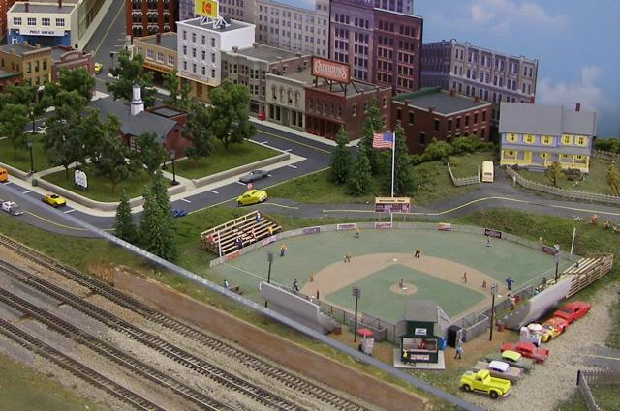

Hitahomer Field is full of excitement in our little town of Bagelton. It must be an important game because there isn’t much happening on the downtown streets. ☺

I’d like to report that the approach road from the army base up to the bridge is ready for stripping and ditch work. The paving and concrete painting job is complete. That military convoy will be happy to finally be able to back off that dead end bridge!

It’s been observed that we have been having an occasional derailment due to low-slung trip pins on the MT couplers. Your coordinator (me) almost always has the MT coupler gauge in the tool kit to check such things as coupler and pin height. Just a gentle reminder that a little up front effort can save a lot of car chasing, roundups, unplanned uncoupling and derailments on the railroad.

Take a note from our calendar that the live steam spring fling in Columbia TN is quickly approaching. This is a free event and makes for a great day trip. We’ve posted pictures of previous trips and, well, you just got to go at least once.

I will close for now by encouraging all of us to continue utilizing our web site at www.knoxmodelrailroaders.com. Sharing anything about trains (and food) is good!

Large Scale Rails - Jim Schall
The Wednesday niters seem to be having the same problem that the club in general is having --- there is too many demands on our time and not enough time to do everything we would like! This past week Fred, Ken and Lance were all in a travel mode. I missed the previous week because of a church meeting that I had to attend and Ken was on his way north. I am certain this lapse in attendance (notice I did not say progress!) will soon rectify itself and we will live happily ever after.

Frank and Brad are continuing to work diligently on the Flyer layout and are putting the “scalers” to shame. Hopefully their ambition will be infectious and the scalers will get moving again. I am beginning to think that we scalers are becoming a gaggle of geezers, but I have to admit I do enjoy the socializing and hate missing a session.

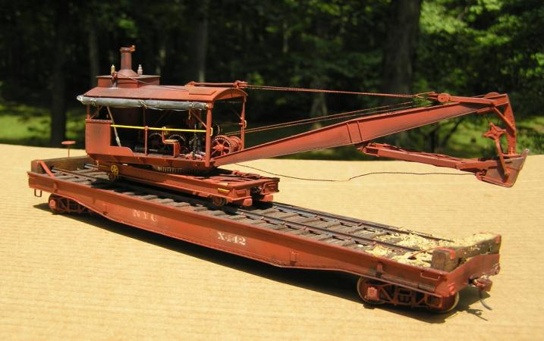

Some of you may not have seen the one page article in S Gaugian magazine about this rail ditcher that I did for a fellow in California. It is kind of scary chopping up an expensive brass model that is not yours but the man was pleased and I was relieved. (ed.)

Activities Calendar
In an effort to get more of us to use our web site the calendar has been moved to knoxmodelrailroaders.com. This should get more of us to the site and hopefully to participate in the exchange of ideas and info that is found there.

