The SCOOP
April 2007 Vol. 21, No. 4
The newsletter for the Knoxville Area Model Railroad Club, Inc.
Editor: Jim Schall, phone - 423 369-2955, email - Schallj@highland.net
Website : knoxmodelrailroaders.com

Conductor’s Comments - Larry Burkholder, President

HO Division – Alex Cameron
This is not going to be much different than March. No big changes in store for April. We will continue what has now become our routine schedule. We will have regular club Sunday meeting on April 1 and 15, starting about 1:30. Thursday work sessions are on April 5, 12, 19, 26, starting at 9:30. Saturday work sessions on April 7 and 21, starting at 9:30.
The third Sunday meeting/open house/run session was poorly attended, and only one train was run, along with a member's new 2-6-6-2. We did not have many visitors.
Construction attendance in March varied from 3 to 8, and steady progress has been made, again. I can't think of any major projects completed. We did install a display to show the status of the four switches on the lower loop, which should make it easier to tell what your train will do there without having to go and look at the toggle switches.
There was a lot of discussion during the month about the proposed engine terminal design. Dick Brion incorporated many of those suggestions, and we have now a design that he is proceeding with. One major question yet to be settled concerns the turntable. Should we purchase one or does a member want to build it? If purchased, which one should we buy? I would appreciate feedback.
Remember that the third Sunday is a run day, so come and run trains.
N-Scale Activities - Bruce McElhoe, N Coordinator - hmcelhoe@aol.com
Last months issue with track warping is now history or at least it’s a semi-long term temporary opinion that all mainlines are now back in conditionally PERFECT operating order. ☺

The following photo depicts how far ranging our layout goes in order to show real world scenes.
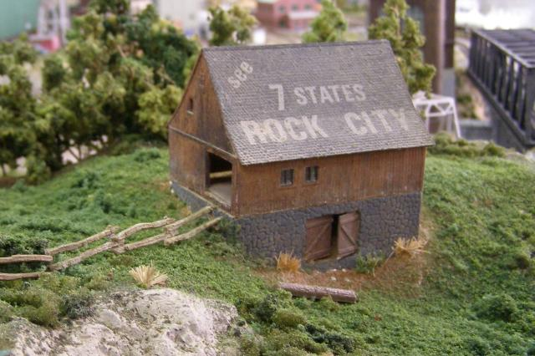

We all know that one of the important things to remember about this advertised tourist destiny is the view of seven states! From the n-scale perspective this relates to the State of:
Mind,
Confusion,
Indifference,
Chaos,
Bewilderment,
Pestering, and
Bagels. ☺

On a more down to earth note, Phil Brooks did perform some needed surgery on the door jam to correct the issue with the warped frame. So far the repair seems to help with the alignment of the latch so it’s easier to secure the door leading out into the museum area. No other problems of track warping have cropped up. An inspection of all jumper track sections between modules showed that there isn’t any binding and in fact all seem to have adequate gapping to allow expansion sue to the temperature and humidity changes. For now, I’m crossing this item off the "to do" list.

I will close for now by encouraging all of us to continue utilizing our web site at www.knoxmodelrailroaders.com. Sharing anything about trains (and food) is good!

Large Scale Rails - Jim Schall
Our Wednesday night-out has turned into a general chat session. Not much has been done lately on the S scale layout but the AF layout has been getting some attention from Brad and Frank (and friends!) Seems like one or more of us are missing each session, due to illness, travel, whatever.

A couple of us are talking up a trip to the national convention --- the S scale one in Baltimore. That is the farthest south it has ever been --- sorta gives you a clue where the hobbyists aren’t! Southerners and Southern RR modelers in S are rare birds but fortunately Jim King from Smokey Mountain Model Works has joined the ranks of S scalers and has received accolades upon accolades in his first effort, the Southern low side gondola. It has sold better in S then the O scale version that preceded it . He is very pleased by the S scalers response and now has a CG ventilated box car in the works. He continues to create kits in HO and will be introducing a CG 40 ft pulp wood car at the RPM Convention in Savannah this month.

Regional Events:

Western North Carolina Train Show - Mark your calendars for Saturday, March 31st and the fifth annual North Carolina Railroad Expo. The show is at the Hickory NC Metro Center located at Exit 125 off Interstate 40. Show hours are 9am-4pm.
There will be close to TWO HUNDRED FIFTY tables of models, rrdiana, videos, photos, books, shirts, and more. This includes five operating layouts, good food, FREE PARKING, and only $3 admission for adults. A Thomas train will be there for the kids as well.
Come by and say hello! Hickory is convenient to Charlotte, Winston Salem, Greensboro, Roanoke, Asheville, Knoxville, Greenville, and Atlanta. Within an hours drive are the Asheville loops, Spencer Shops, Alexander Railroad, Caldwell County RR, and various train-watching locations along NS and CSX. There are lots of furniture, malls, and theatres for your significant other as well.
Proceeds from the show will benefit the restoration of the Alexander Chapter's newly acquired narrow gauge Lawndale Railway boxcar.

Activities Calendar
In an effort to get more of us to use our web site the calendar has been moved to knoxmodelrailroaders.com. This should get more of us to the site and hopefully to participate in the exchange of ideas and info that is found there.

